**Math 1200 -College Algebra for Business names**

**Introduction to Excel II: Tables, Charts, Graphs, and Calculations**

*During this course, we will periodically use Excel to help us analyze data. You should hold on to this tutorial and refer back to it as needed. You can save a file of your work to the desktop and email it to yourself if you want to keep a copy.*

0. Housekeeping – Put the names of all the group members on the first sheet of an Excel workbook. Save the file with the name Excel2Name1Name2Name3.xlsx where Name1, Name2, etc are group member names,

1. Creating a column chart in Excel

The following table contains a breakdown of the types of vacations people in different age groups went on in a 12-month period. Enter this data into sheet 2 of your Excel workbook. You can do this by either retyping everything, by or copying from the word document and pasting into cell A1 in Excel.

|  |  |  |  |  |
| --- | --- | --- | --- | --- |
|  | All | 18-24 | 25-34 | 35-44 |
| **Visiting friends/relatives** | **62** | 62 | 65 | 59 |
| **Beach/resort** | **30** | 32 | 39 | 29 |
| **City-based** | **30** | 41 | 33 | 27 |
| **Lakes and mountains** | **19** | 27 | 22 | 16 |
| **Camping** | **15** | 19 | 21 | 17 |

1. Use this data to create a bar chart in Excel that represents the breakdown of vacation type distribution for All.

* Select the first two columns.
* From the charts tab select column chart.
* Click on the title and edit the title. Click “Axis Titles” and add Horizontal and Vertical axis titles to your graph.

**Your graph should look like this:**

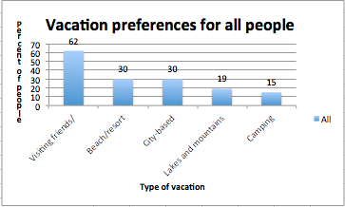

1. Repeat the exercise with 25-34 year-olds. (Select first set of data, press/hold CTRL while selecting second set of data.)
2. Using two different age groups, repeat the data, using stacked columns.
3. Document your work with appropriate text boxes and labels.

2. Creating a scatter plot in Excel

The following data contains the in-state tuition cost for ESU for the years 1999 - 2009. Enter this data into Excel. **Let *x* represent the years since 1999 (use column 2 for the x values)**.

|  |  |  |
| --- | --- | --- |
| Year | **x-value** | **Tuition (y-value)** |
| 1999 | **0** | **$3,587** |
| 2000 | **1** | **$3,650** |
| 2001 | **2** | **$3,675** |
| 2002 | **3** | **$3,918** |
| 2004 | **5** | **$5,138** |
| 2005 | **6** | **$5,445** |
| 2006 | **7** | **$5,819** |
| 2007 | **8** | **$6,196** |
| 2008 | **9** | **$6,779** |
| 2009 | **10** | **$7,117** |

A) Use this data to create a scatter plot in Excel that represents the increase in ESU tuition over time.

* Select columns 2 and 3.
* Click on the Insert Tab and select Scatter Plot.
* Add a title to your graph and label the axes.
* Click the Plus Sign to the right of the chart. Click “Chart Title” and add a title to your graph. Click “Axis Titles” and add Horizontal and Vertical axis titles to your graph.

**Your graph should look like this:**

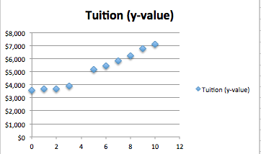

B) With the same data set create a marked scatter plot. Also use some other kind of plot with the data.

C) Try the same thing with all three columns.

3. Creating a marked scatter plot in Excel for several functions

A) Make a table with columns x, and the four functions 2x-3, 3x+5, 3x-10, x^2/10, with x going from -10 to 10 by 1.

B) Make a marked scatter plot for all 4 functions.

C) Make a marked scatter that graphs the first (2x-3) and 4th (x^2/10) function. (You need to use command click to select data columns that are not next to each other.

D) For comparison, graph the same 4 functions with Desmos. Do a screen clipping and paste the image into Excel.

When you finish your worksheet, make sure to share copies with the group and then submit it on blackboard.